  
  NEWSLETTER
  JANUARY 2023

Error! Unknown switch argument. | Share This Email

Error! Unknown switch argument. | Share This Email

Error! Unknown switch argument. | Share This Email

Rob Hilliard, State Commander

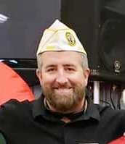

From the Commander's Desk

Welcome, fellow members, to a new year. Time does seem to fly by at a blazingly fast pace as we all progress in age.

This upcoming second half of the year is a hectic time for all of us DAV members. Coming up at the end of February is Mid Winter out in D.C. That week will be a time of training, and we will meet with our State representatives from the house and the senate. This is also when the DAV National Commander gives their testimony to the joint house on veteran affairs.

We are also busy getting the final loose ends for the Spring Conference tied up.
I wanted to hold this event somewhere up north, but after five months of searching, we came up empty, because there was not a venue that could provide the needed rooms. Or the venues could not meet the amount of conference room space or food needs.

So with short notice, Green Bay was the only Hotel that would work with us on this short time limit and for only one night. Plus, cost-wise, they provided the most bang for the buck and saved the DAV valuable dollars.

The Spring Conference is new this year and is on a trial basis. I want to see if we can hold a more efficient way of conducting the way we do district meetings. If this plan works, we can do all district meetings at one place over one late afternoon and one morning. This will also save the Department money that can go to veterans programs instead of meetings.

Also, we are working diligently on the Summer Convention. My team and I want to provide our members with the best product we can put forth. I want to ensure that all of the DAV business gets done at these events in the most efficient manner possible. I also want to ensure that our members can have any and every question they may have answered at these events.

﻿I must put out a product so that our members enjoy their limited and valuable time while at these events. When it comes to these types of events, they are first and foremost for each and every member of the State of Wisconsin.

I look forward to sharing with you what we learn during Mid-Winter. So stay warm, and don’t overdo it with the snow shovels. Please take time to remember our brothers and sisters that we have lost and their family members that they may have lost over the holiday season.



Greg Palo, State Senior Vice Commander

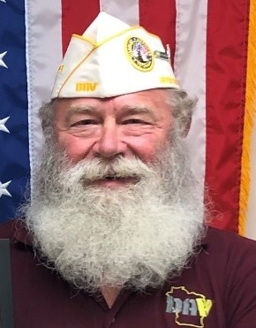

Sixty-six percent of our Department Chapters have made progress in reaching their goal. However, our Department needs 307 new members to reach our goal before June 30, 2023.

We have had eight Chapters take advantage of the $25.00 incentive to claim a Hot List from National, and of that, we had four Chapters claim reimbursement for their recruitment efforts. So, as of January 2023, we have three Chapters at or exceeding the goal.

Do you have Recruit A Warrior on your electronic device? This is the quickest way to recruit a new member and ensure that you and your Chapter get the credit. National has a QR code for you, which is helpful with Recruit A Warrior. Go to dav.org/warrior to receive your QR code. If you want a business card generated with your QR code, go to http://dav.la/38v.

For questions about ordering business cards, email fulfillment@dav.org. For questions regarding Recruit A warrior links, send them to membershippublic@dav.org.

﻿March Madness is coming again this year. National has not given the details yet, but they will be coming soon. So maybe this year, we will give other Departments a run for their money!

Pat Lillis, State Junior Vice Commander

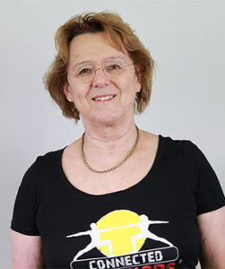

For this Newsletter I’ll again combine information from my role as First Senior Vice as well as Chair of the Women’s Committee for WI. I have to start off on a sad note, and that is we lost one of our Committee members after a long illness. Joanne LaCoursiere was also the Commander of Chapter 55 in WI Rapids. Even though she had been ill a long time, she was always upbeat and working issues for the DAV, even attending our annual meeting. So, this was very unexpected to us, and we miss her. Commander and senior members of the DAV were able to attend her funeral and render appropriate honors befitting our honored member. A special personal remembrance was sent from the members Women’s committee, and we received a heartfelt letter of gratitude from the family.

Though the holidays were quiet, the members of the Women’s committee were able to obtain the names of most of ladies (women veterans) who are residents in the Veteran’s Homes at King, in Chippewa Falls and at Union Grove. We also tried to include any women veterans who were employees with our specially designed cards, and we really want to thank out Senior Vice Greg Palo and the DEC leaders who assisted us in this endeavor. Due to privacy issues, we were only able to obtain first names. We have more plans for next Christmas; we thought this was an important activity as women generally live longer than men and we were concerned that they may have few visitors.

And finally, I had the honor of being able to represent the DAV on a Committee of the National Academy of Science preparing a report on “Whole Health” for the VA. It has taken a year and half, but we have finished, and the report is due out mid-February. DAV members will be happy with the recommendations, and as soon as cleared to do so, I look forward to telling everything there is!

David Felten, State Junior Vice Commander

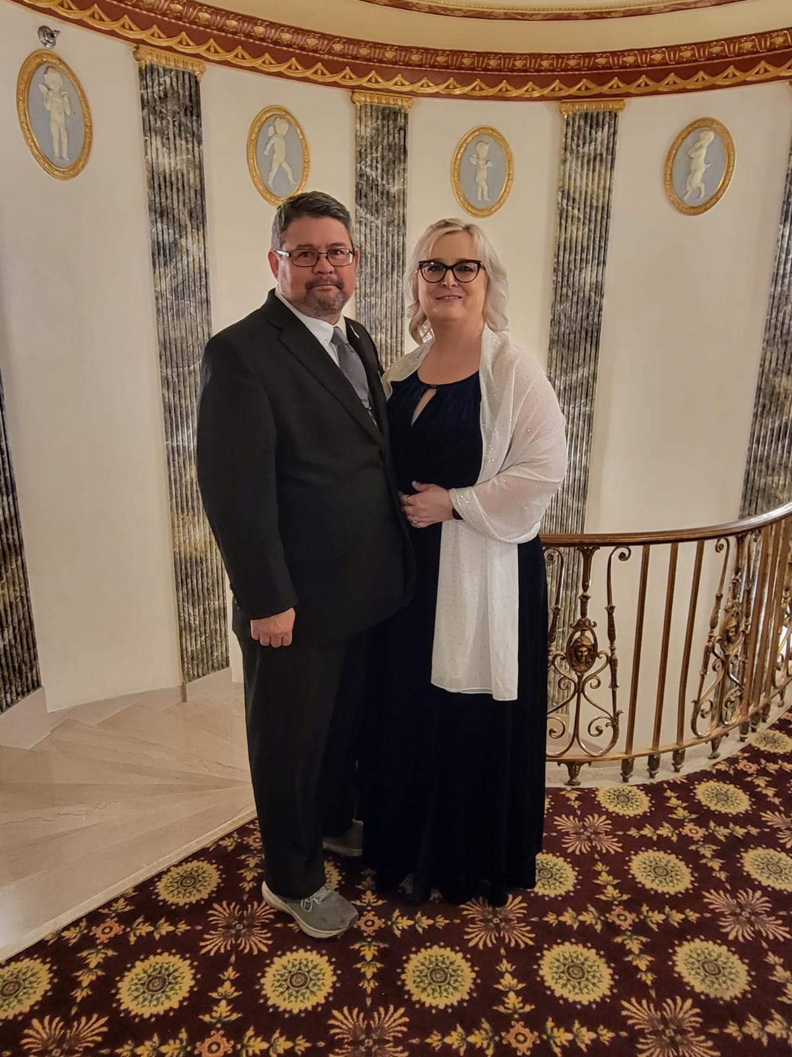

I hope everyone had a wonderful holiday. My favorite gift was to be with my family and of course I also received the Death Star tree topper! However, now that the holidays are over lets look at the Local Veterans Assistance Program, LVAP, hours, per chapters. From July1, 2022 thru January 20, 2023, your chapter has LVAP hours per our DAV National:

#2 Madison – 1,667 #24 Manitowoc – 3,946 #51 Redgranite – 941
#3 Greenbay – 2,985 #27 Monroe Co. – 1,771 #52 Northwest – 2,833
#5 Waukesha – Zero #28 Ashland – Zero #53 Manawa - Zero
#8 Baraboo – Zero #29 Lincoln Co. – Zero #55 Wis Rapids – 969
#9 Racine – Zero #30 Stevens Point – 243 #56 Eagle River - Zero
#11 Fond du lac – 12 #31 Medford – 1,085 #57 Marshfield – 1.978
#12 LaCrosse – Zero #32 Richland Ctr. – Zero #58 West Bend - Zero
#14 Rock Co. – 62 #33 Rock Co. – 573 #60 Portage - Zero
#17 Winnebago Co. – 3,007 #34 Twin Co. – Zero #62 Rhinelander - 47
#18 Outagamie Co. – Zero #38 Juneau Co. – 715 #63 Watertown - Zero
#19 Milwaukee – 12 #40 Grant Co. – Zero #64 Wausau - Zero
#20 Kenosha – Zero #42 Marinette – Zero #65 Calumet Co. - Zero
#21 Chippewa Valley – 3,539 #44 Milwaukee – 1,072 #67 Mineral Point - Zero
#23 Antigo – Zero #45 Oconto Co. – 794

We have a emerging winner - congratulation Chapter #24; some contenders – Chapters #21-#17-#3; and a lot of chapters at Zero. So far the emerging winner individual for the most LVAP hours are coming from Chapters #3, #21, #57 and contenders from Chapter #2 and #27. The competition is not over until June 30, 2023. If you see that your chapter neighbor is at low or Zero hours, please try to help them.

Currently our Wisconsin DAV is sitting at the 7th position with 28,255 LVAP hours. South Carolina is leading the nation with 135,161 LVAP hours. It’s not to late to move up to the top. However, we need every chapter to participate! I know we all are helping veterans and their families enrich their lives. So, just record it and give us a more powerful voice in Washington. If you are having meetings, talking about it, helping any veterans…..etc. you need to submit your Monthly Reporting Form 60 – LVAP to vans@dav.org. If you need help watch the webinar and all the information is at Voluntary Services - DAV. talk to your district chapters or give me a call (920) 410-8512 or email dfelten33@gmail.com. If this doesn’t work, I can always come and visit.

Tiffany Koehler, State Junior Vice Commander

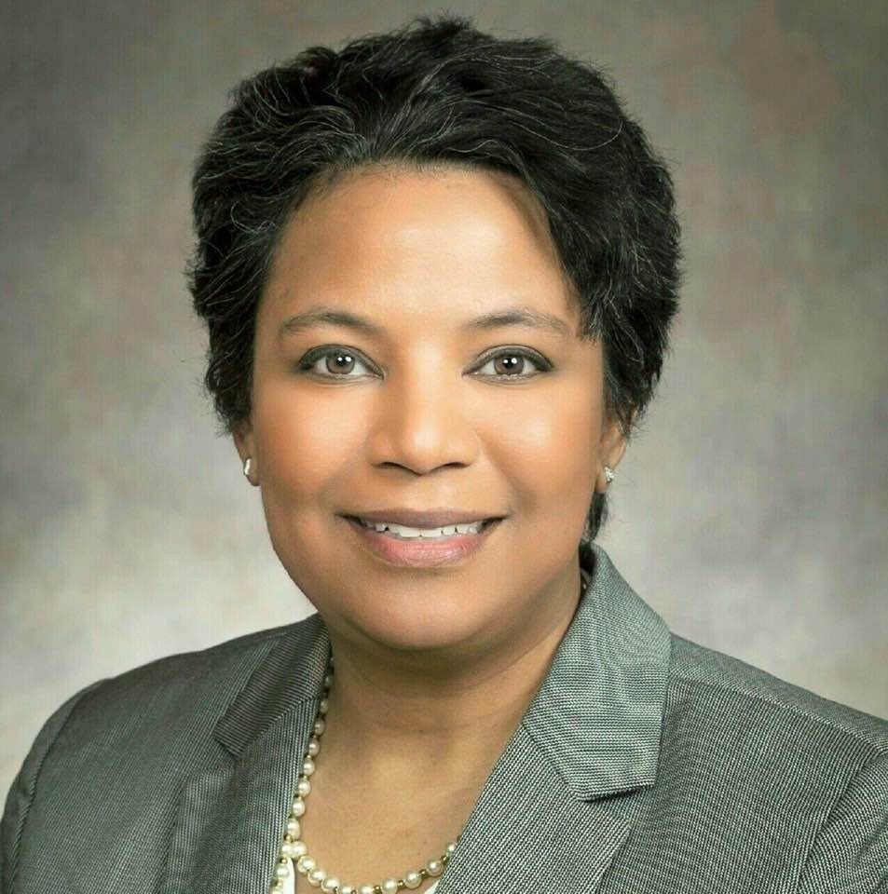

I hope this information finds you well. I wanted to update you with important information regarding DAV’s youth scholarship awards and the dates you should be aware of. To be eligible for an award a youth must be age 7 to 18 years of age who are still in school and who volunteer in the name of the DAV or DAVA.
Here are the ways that volunteer work can occur in one or more of the following activities: Volunteer at the Wisconsin Veterans Homes. Participate in DAV, Veterans , Flag or Memorial Days. Help at food pantries, visit house bound Veterans, visit nursing homes, create an Americanism project, and any way you can think of to help Veterans and their families.
They could be awarded the following:

1. 1st Place: $250 Check and a Certificate of Appreciation
2. 2nd Place: $150 Check and a Certificate of Appreciation
3. 3rd Place: $100 Check and a Certificate of Appreciation

All Department Officers, DAVA Chapter, DAVA Unit Members, VAVS, and HSC staff can nominate a youth for these awards.
The period of volunteer activity used for judging will be from April 1, 2022, through March 31, 2023.
Nominations must be submitted to DAV Department of Wisconsin no later than May 20, 2023. Tell us why you think your nominee is the best to receive an award, the activity they participated in, and the number of hours they served. The winners will be notified by phone so please include their phone number within the nomination submission.
We look forward to reviewing the applicants and learning about all the good things they are doing in the name of DAV and/or DAVA!

Michael Hert, State Chaplain

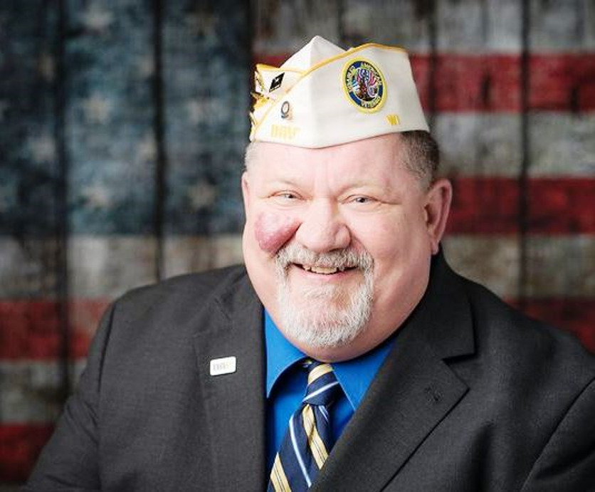

I have always enjoyed this time of the year. The joy of the holidays is behind us, and a fresh new year is in our sights. Any lessons learned from the previous year have been placed in our back pocket while those victories of 2022 have been made part of our daily toolkit. Yet the coming year is always viewed as an unblemished product, waiting for us to venture forward. It can be a thrilling and exciting time of our lives as we step forward into some new adventures. While some goals may be geared toward losing weight, working out, etc..…. My thoughts are toward the personal and spiritual realm. What can I do to be a better human being? What can I do help others? What can I do help alleviate the suffering in my local community? As a DAV member, what can I do to touch the lives of my fellow Veterans? Can I connect with a fellow Veteran that is lonely. Can I reach out and touch the lives of older Veterans at one of the VA Nursing homes within the area? In a nutshell, the opportunities are many so when making your plans for 2023, please think about reaching out to those who maybe hurting. Our mission is to ensure our fellow Veterans live life’s of dignity and respect. Be the difference!

Julie Hert, DAV Auxiliary State Commander

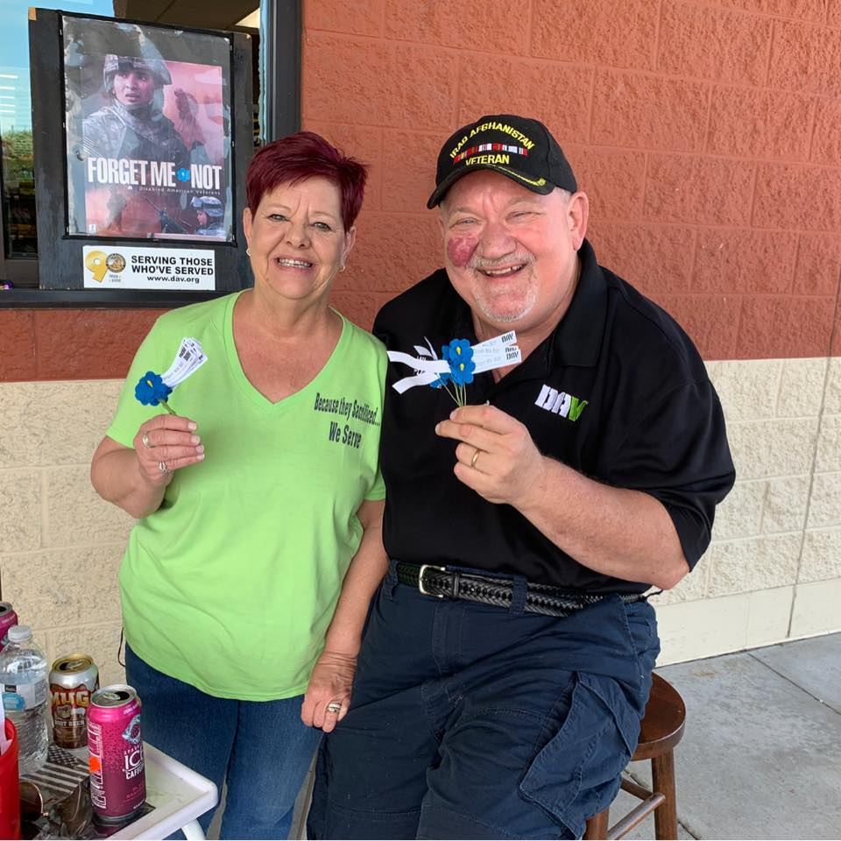

I hope that everybody had an enjoyable Holiday season as we move into the New Year. I’m excited about the upcoming months as we start to transfer to more of a post pandemic time of life. First, time moves along quickly and before you know it, the State Auxiliary Convention will be here. I encourage Units to make that final push to getting their membership goals over the finish line. All Units have weathered the pandemic and are meeting again. We are truly a resilient group! Also, if you need any assistance with updating your Constitution & By-Laws, increasing membership, or the rituals of the DAV Auxiliary, please contact your leadership team, we are here to be of service to you.

In terms of myself, I truly enjoyed the Holidays and had some great times with our DAV and Auxiliary members. I did attend the Driver and Volunteer Appreciation luncheon for those who serve our fellow Veterans at the CJ Zablocki VA Hospital. Patty Davis, did a great job organizing the event. I did attend the King VA Recreation Committee meeting this last month plus next month will have a tour of the new Moses Hall.

Lastly, I will be wrapping up as your Commander at the State Convention. There will be movement within the State Auxiliary Officer level. If your interested, this would be a great time, to inquire about the leadership positions. If not you, who??

﻿God Bless and keep up the phenomenal work! Together we make a difference in the lives of Veterans.

Greg Palo, State VAVS Chairman

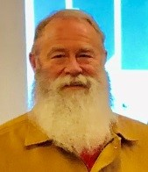

Did you know there is assistance available for veterans struggling to pay heat and rent? WDVA's Veterans Outreach and Recovery Program (VORP) can connect veterans with local resources and community partners that assist with rent and/or utility costs during winter.

WDVA's Veterans Outreach and Recovery Program is committed to providing the most comprehensive services and assistance to our veterans and community partners. In keeping with State and Federal guidelines, WDVA continues to reference the Wisconsin Department of Health's website as it relates to COVID-19 and adjusts its procedures accordingly to how they treat, connect, interact, and reach out to their community partners and veterans in need. They can schedule in-person meetings when it is safe for both staff and veterans. When face-to-face meetings are impossible, they utilize Microsoft Teams to best connect with community partners and veterans.

The WDVA coordinators are available via phone and email during regular business hours to answer any other questions and to offer support to veterans and community partners.

Funding assistance will vary based on each veteran's eligibility requirements, and VORP coordinators can guide the veteran while navigating these resources in their counties.

﻿To determine your eligibility for this assistance, don't hesitate to contact the regional outreach coordinator for where you live, the Veterans Outreach and Recovery Program (VORP).

Matthew Kempainen, State Adjutant

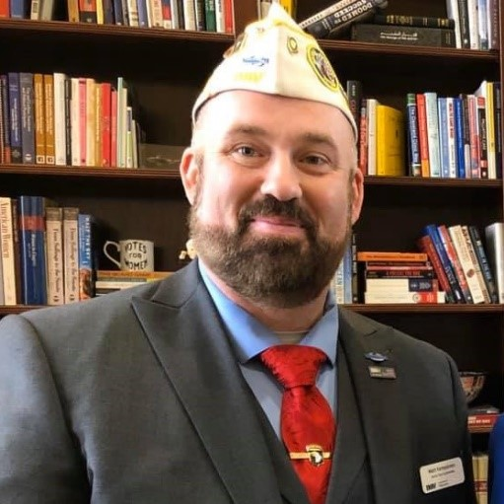

I hope that everyone’s holidays were happy. Commander Hilliard has started 2023 by scheduling a Spring Conference on April 21st and 22nd. This conference is being held as a two-part event; one will distribute the information we receive from Mid-Winter, and the other will be the District meetings. We will have the registration and tentative agenda sent out soon as we are currently putting things together.

The DAV National has Mid-Winter coming up at the end of February. For those who do not know what Mid-Winter entails, it is in Washington D.C; the National Commander gives their report to a Congressional Committee about the legislation that DAV supports and would like to see passed by Congress. It is also where DAV members from each state sit down with their congressional representatives and let them know where we, constituents of their districts, would like to see them support the DAV legislature. To go to Mid-Winter, you do not have to be a Dept. of WI line officer. But if you decide to go, please let us know at the Headquarters so we can set up meetings with your district representatives.

After Mid-Winter, Commander Hilliard and I will be getting ready for the upcoming events of the Spring Conference, State Convention, and Fall Conference. We want to make these events full of great information, training, and fun. Make sure you are logging your LVAP hours to win your Division trophy. Also, if you have or know of any kids out there doing LVAP for you or a Veteran, you know, get them in for the DAV Dept of Wisconsin youth award. We want to see people get credit for all the amazing work they are doing.

﻿I know we are in a slow time of the year but remember that the holidays were not the best for some of the members out there, and there are not many events going on right now. Make sure you are doing buddy checks, and go out for lunch, breakfast, or dinner with a friendly neighborhood DAV member or veteran. We are the only ones who know what others have been through, and your smiling face may make someone’s day.

